College Of Engineering
Artificial Intillegence Department
Project: Smart care hospital
Author:
Tasneem Alazzawi

Introduction
The SmartCare Hospital project is designed to build a complete hospital management database system using SQL. The purpose of this project is to organize and manage hospital information such as departments, doctors, patients, appointments, medical records, bills, medicines, and prescriptions.
The system is based on a Relational Database structure, where data is divided into related tables to improve organization, reduce duplication, and ensure data accuracy. This database helps hospitals manage their daily operations efficiently and allows quick access to important information.

Explanation of Database Tables

1. Departments Table
The Departments table stores information about all hospital departments such as Cardiology, Neurology, Emergency, Surgery, and others.
This table contains:
- Department ID
- Department Name
- Floor Number
Each department has a unique identifier to distinguish it from other departments.

2. Doctors Table
The Doctors table contains information about doctors working in the hospital.
The stored information includes:
- Doctor’s full name
- Medical specialization
- Phone number
- Salary
- Department assignment
This table is connected to the Departments table using a Foreign Key, which means every doctor belongs to a specific department. The phone number field is unique to prevent duplicate entries.

3. Patients Table
The Patients table stores personal and medical information about patients registered in the hospital.
The table includes:
- First name
- Last name
- Gender
- Birth date
- Blood type
- Phone number
- Address
This table allows the hospital to maintain patient records and retrieve patient information whenever needed.

4. Appointments Table
The Appointments table is used to organize appointments between patients and doctors.
Each appointment contains:
- Patient information
- Doctor information
- Appointment date and time
- Appointment status
The possible appointment statuses are:
- Completed
- Pending
- Scheduled
- Cancelled
This table is linked to both Patients and Doctors tables to identify which patient is meeting which doctor.

5. Medical Records Table
The Medical_Records table stores the medical history of patients.
It includes:
- Diagnosis
- Treatment
- Visit date
This table helps doctors review previous patient conditions and treatments for better healthcare management.

6. Bills Table
The Bills table manages patient billing and payment information.
The table stores:
- Total bill amount
- Payment status
Payment statuses include:
- Paid
- Unpaid
- Pending
This table helps the financial department track hospital payments and outstanding bills.

7. Medicines Table
The Medicines table stores information about medicines available in the hospital pharmacy.
The stored information includes:
- Medicine name
- Available quantity
- Expiry date
- Price
This table helps monitor medicine stock and manage pharmaceutical inventory.

8. Prescriptions Table
The Prescriptions table records the medicines prescribed by doctors to patients.
The table contains:
- Patient information
- Doctor information
- Medicine information
- Dosage instructions
This table is connected to:
- Patients table
- Doctors table
- Medicines table
These relationships create a complete prescription management system.

Relationships Between Tables
The project uses relationships between tables to organize data properly.
Important relationships include:
- One department can have many doctors.
- One patient can have many appointments.
- One doctor can manage many appointments.
- One patient can have multiple medical records, bills, and prescriptions.
- One medicine can appear in multiple prescriptions.
- One doctor can have many prescriptions
Using relationships helps:
- Reduce data duplication
- Improve data organization
- Simplify searching and reporting

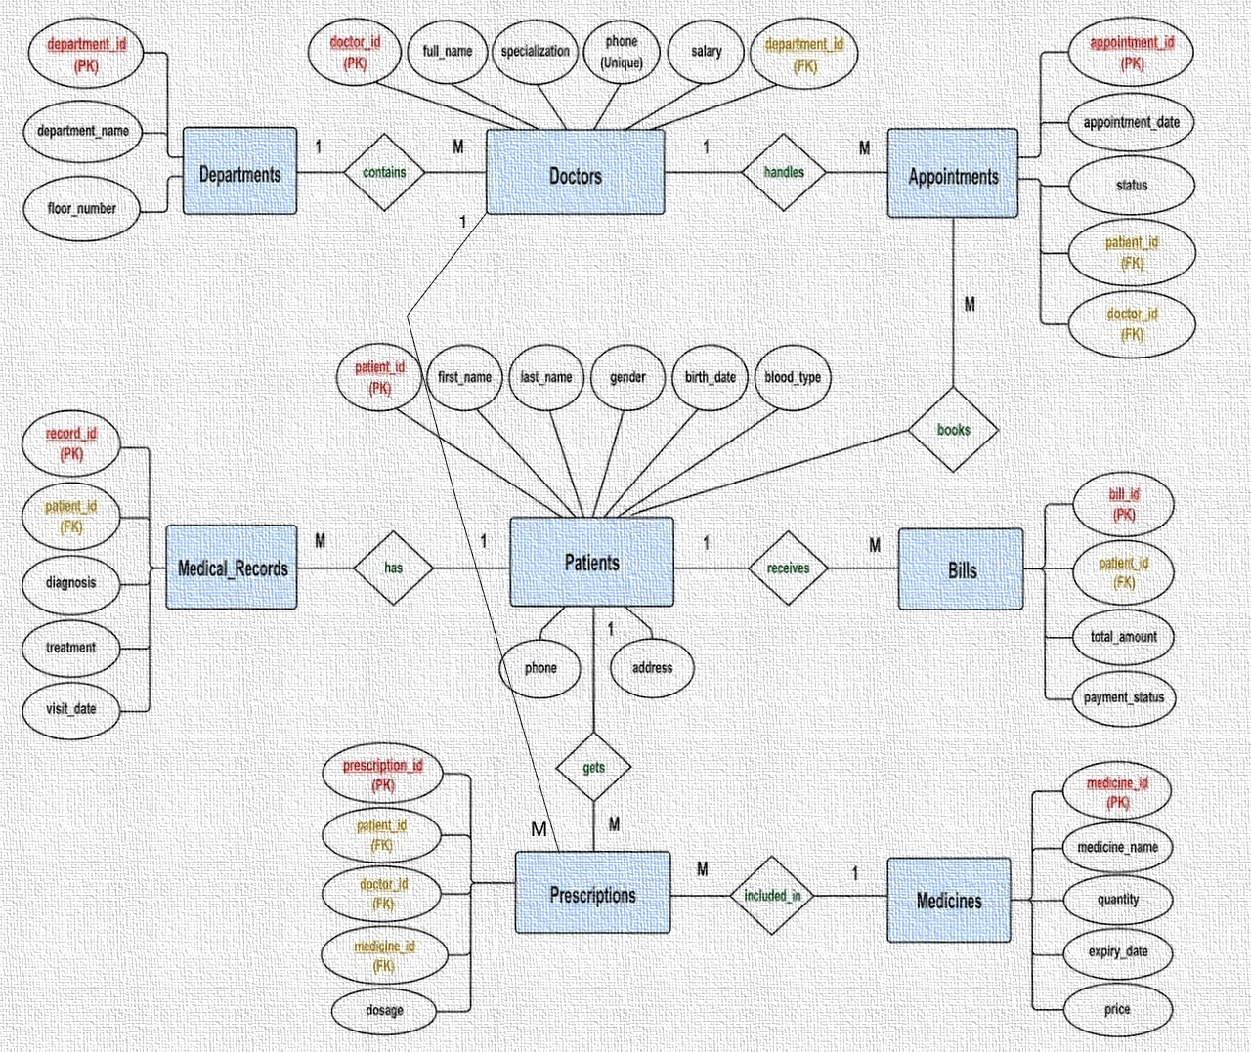

We have some database-specific queries that we created.
1/ Max salary
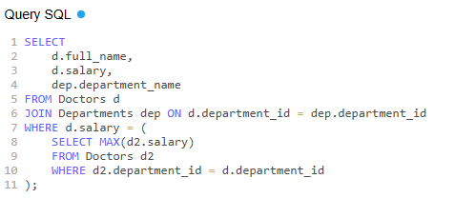
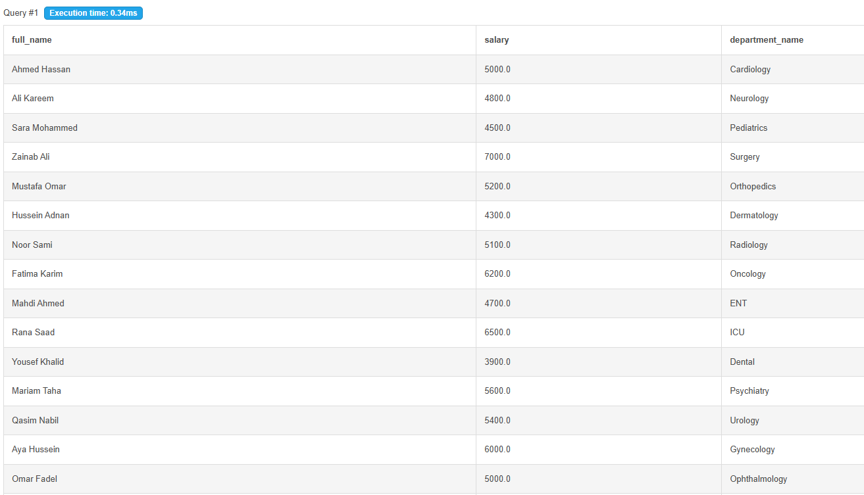

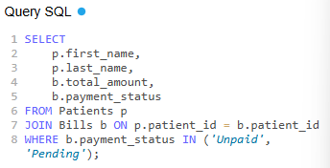
2/ Unpaid bills

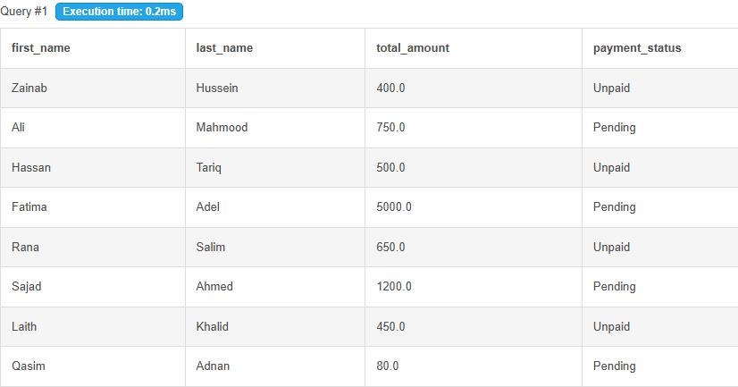

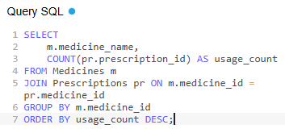
3/Most commonly prescribed medications

